Lab 5

**Objectives:**

The objective of this lab is to apply Markov Chains to solve problems involving probabilities over multiple stages. The lab consists of two problems: The first problem focuses on weather prediction, where we use the transition probabilities to calculate the probability of a specific weather condition (not raining) on the day after tomorrow, given today's weather. The second problem involves modeling consumer behavior with Coke and Pepsi purchases, where the goal is to compute the probability of a person purchasing Coke after two purchases, given the initial condition of being a Pepsi purchaser. By implementing these scenarios in C programming, students will gain practical experience with Markov processes and learn to calculate state transitions over multiple steps.

1. **WAP to solve the below Weather problem**

**Rainy today => 40%**

**Rainy tomorrow => 60% not Rainy tomorrow**

**Not rainy today => 20%**

**Rainy tomorrow => 80% not Rainy tomorrow**

**What will be probability if todays is not raining then not rain the day after tomorrow?**

**Source Code:**

#include <stdio.h>

int main() {

float P_notRain_today = 1.0; // Given that today is not rainy

float P_notRain_tomorrow = 0.8;

float P_rain_tomorrow = 0.2;

float P_notRain_given_notRain = 0.8;

float P_notRain_given_rain = 0.6;

// Calculate probability

float P_notRain_day_after = (P_notRain_tomorrow * P_notRain_given_notRain) +

(P_rain_tomorrow * P_notRain_given_rain);

printf("Probability of not raining the day after tomorrow: %.2f\n", P_notRain_day_after);

return 0;

}

**Output:**

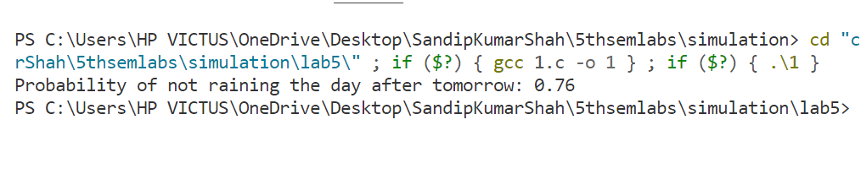

1. **Coke – Pepsi**

**Coke => 90% Coke**

**Pepsi => 20% Coke**

**Given a person is currently a Pepsi purchaser. What is the probability of purchase of coke after two purchases from now? WAP to solve the above problem.**

**Source Code:**

#include <stdio.h>

int main() {

float P_C_given_C = 0.9; // P(Coke | Coke)

float P_C_given_P = 0.2; // P(Coke | Pepsi)

float P_P_given_C = 0.1; // P(Pepsi | Coke)

float P_P_given_P = 0.8; // P(Pepsi | Pepsi)

// Initial condition: person starts with Pepsi

float P_C_2_given_P_0 = (P_C_given_P * P_C_given_C) + (P_P_given_P * P_C_given_P);

printf("Probability of purchasing Coke after two purchases: %.2f\n", P_C_2_given_P_0);

return 0;

}

**Output:**

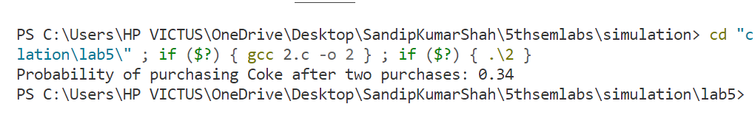

**Conclusion:**

In conclusion, this lab successfully demonstrated the application of Markov Chains to model real-world problems involving transitions between states over time. The weather prediction problem helped us calculate the probability of a specific weather condition based on conditional probabilities, and the consumer behavior problem provided insight into how past purchases influence future behavior. By solving these problems through programming, students gained a deeper understanding of probability theory, specifically how Markov processes are used to model dynamic systems and calculate probabilities over time. This lab enhanced our ability to apply theoretical concepts to practical, real-world situations.